**LAB MANUAL 6**

**LAB TASKS:**

1. A screenshot of a computer

   Description automatically generatedGenerate the Fibonacci sequence using nested loops.
2. 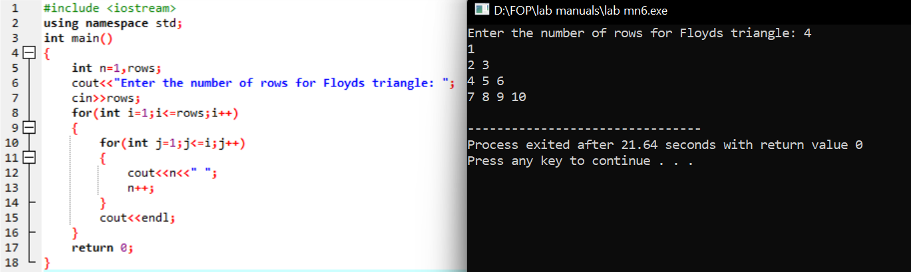Create Floyd's triangle with nested loops.

**HOME TASKS:**

1. Write a program using break or continue statement that only adds prime numbers from 1 to 50 and display the sum on screen.

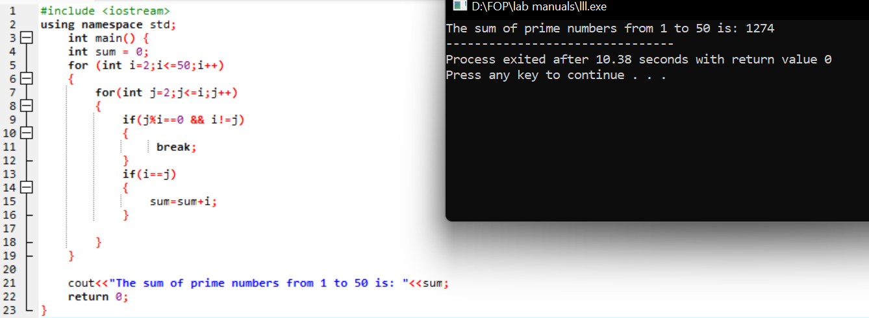

1. Write a program in C++ to create the following pattern.

1

1 2

1 2 3

1 2 3 4

1 2 3 4 5

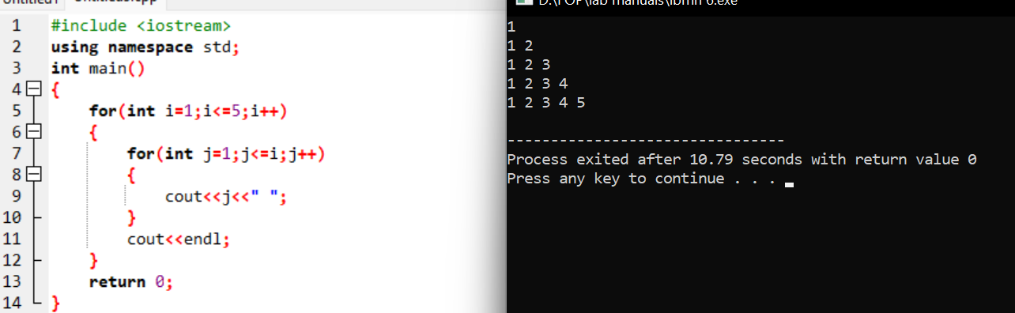

1. Write a C++ program to print:

1

2 2

4 4 4 4

6 6 6 6 6 6

